**Performance Assessment: D212- Association Rules and Lift Analysis**

**A. Research Question**

**1.** For this assessment, the research question is at follows: using market basket analysis, can we discover patterns of prescription drugs being prescribed together?

**2.** One goal of this data analysis is to discover combinations of prescription drugs that are frequently prescribed together. By doing so, we can develop further insights into the safety of different drug combinations and other trends.

**B. Market Bracket Justification**

**1. “**MBA uses either the association rule or if-and-then statements” (“FAQ: What is Market Basket Analysis” 2022). What this means is that MBA takes transactional data and uses the apriori algorithm to look for patterns of transactions based on a user-inputted support and confidence, where support being the percentage of transactions that include the item and confidence being the likelihood of two or more items being included in one transaction. The algorithm uses these metrics to generate an association rules table with a left-hand side and a right-hand side, the LHS being one specific item and the RHS being another item that can be associated with the first based on the support, lift, and confidence, which can be viewed and interpreted accordingly. Using this information, we can expect to be able to discover associations between products and items in order to make better recommendations and notice trends with the items.

**2.** The original CSV file as provided by WGU contains a list of transactions where every row represents one transaction of prescriptions. Here is one example of a transaction: on row 5 there is a transaction showing the prescriptions of citalopram, Benicar, and amphetamine salt combo xr. The following screenshot shows this transaction:

**3.** One assumption of market basket analysis is that is assumes “that customers who purchase a specific item are more likely to purchase another specific item or group of items” (“FAQ: What is Market Basket Analysis” 2022). What this is saying is that the algorithm assumes that buying one item increases the probability of buying another, but the algorithm does not take into accounts things that could lead people to buying additional items such as promotions or discounts.

**C. Data Preparation and Analysis**

**1.** The data was transformed from a raw CSV spreadsheet into transactional data In R, and then converted into a matrix to write into a CSV file. A copy of both the original and transformed data has been attached alongside this written assessment.

**2.** An RScript file of the code has been attached alongside this written assessment, showing its error-free functionality. The values of 0.1 for support and 0.8 were chosen for the algorithm in order to showcase items that occur in 10% in transactions where items on the RHS are purchased 80% of the time in accordance with the items on the LHS. These values are high enough to determine strong associations between each side.

A screenshot is also provided below to showcase the error-free code:

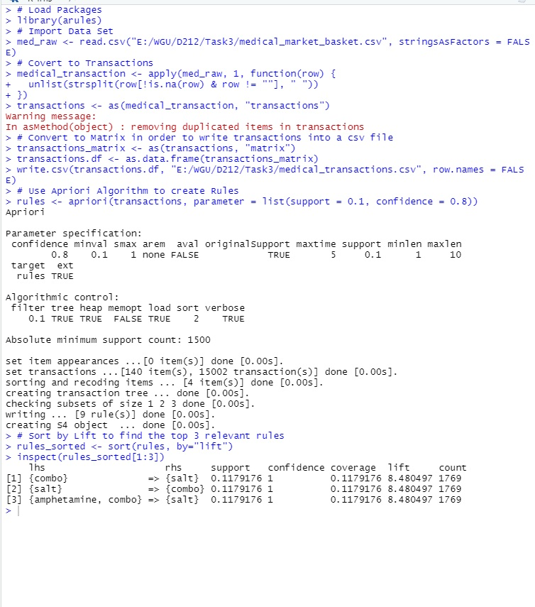

**3/4.** Below is a screenshot showing the top three relevant rules:

The first relevant rule showcases combo on the left-hand side and salt on the right-hand side with a support of approximately 0.1179, a confidence of 1, and a lift of approximately 8.48. The second relevant rule is salt on the LHS and combo on the RHS with the same values for support, confidence, and lift. Lastly, the third relevant rule is amphetamine + combo on the LHS and salt on the RHS with the same values again for all three. Those are the values of support, confidence, and lift for part **C3** as well as the explanation of the relevant rules for part **C4**. The significance and explanation of what these numbers and rules mean will be further explored in parts **D1** and **D2**.

**D. Data Summary and Implications**

**1.** By examining the first rule again, we see combo on the LHS and salt on the RHS. This rule has a support of approximately 0.1179. What this means is that 11.79% of all transactions in the data set contain both combo and salt. This rule also has a confidence of 1 which means that whenever combo is bought, salt is also bought 100% of the time. The lift for this rule is approximately 8.48. This is saying that whenever someone buys combo that they are also 8.48x as likely to also purchase salt. All these numbers indicate a VERY strong relationship between combo and salt. All three of the top three relevant rules showcase the same numbers for support, confidence, and lift, so I will not explain them all individually since they are identical, but these rules also suggest a very strong relationship between amphetamine + combo and salt as well.

**2.** Using market basket analysis, we have identified that combo and salt are frequently prescribed together. In a practical setting, this is significant as it could provide pharmacies to make more informed prescription decisions regarding these two drugs as well as keep better inventory and stock of the two since they have such a strong relationship with each other.

**3.** Based on this analysis, I recommend that we do further research in regard to the safety of these drugs. Since the relationship between them is so strong and they are always prescribed together, further research should be done to ensure that there are no adverse reactions when combining combo and salt.

**E. Sources**

“FAQ: What Is Market Basket Analysis? (Types plus Examples).” Indeed, 22 Oct. 2022, sg.indeed.com/career-advice/career-development/market-basket-analysis.